PUERTAS LÓGICAS

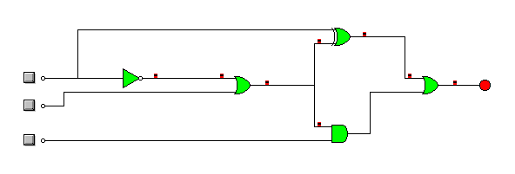

|  |  |  |  |
| --- | --- | --- | --- |
| **A** | **B** | **C** | **S** |
| 0 | 0 | 0 | 1 |
| 0 | 0 | 1 | 0 |
| 0 | 1 | 0 | 1 |
| 0 | 1 | 1 | 1 |
| 1 | 0 | 0 | 1 |
| 1 | 0 | 1 | 1 |
| 1 | 1 | 0 | 1 |
| 1 | 1 | 1 | 1 |

Salida=(a’b’c’)+(a’bc’)+(a’bc)+(ab’c’)+(ab’+c)+(abc’)+(abc)

Salida= a’·(a’+b)+(a’+b)’+(a’+b)·c